How to Port Forward Your Thermostat

What is Port Forwarding:

Port Forwarding is the concept used by your internet router to allow different networks inside your network to communicate with others outside. For example, a network might have multiple computers but only one router IP address. In order for each computer to be able to send and receive requests, they must have their own internal IP. In the same way, in order for your thermostat to communicate with a server outside of your network, it must set up its own address within one of the many “ports” of the router.

How to set up Port Forwarding:

Step1:
Before setting up your port forward, you must set up your thermostat internally. To do so follow the Filtrete setup instructions here:

http://www.radiothermostat.com/filtrete/guides/SettingupWifiXP.pdf

After you do this go to the ADVANCED tab and set the IP address from DHCP to STATIC. Most internal IP address start as 192.168.1.__ fill in the blank with an arbitrary number, say 2: 192.168.1.2

Step2:

Now you must figure out what your router IP address is. To do that, go here:

http://whatismyipaddress.com/

Once you have the IP, enter it into your internet browser. The screen will ask for the username and password of the router.

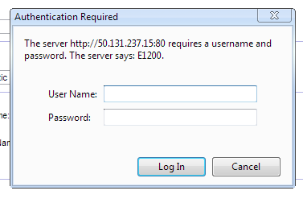

Once inside the router settings page, find the tab which allows you to set port fowarding. For my router which is a Linksys, this is in the Applications & Gaming tab.

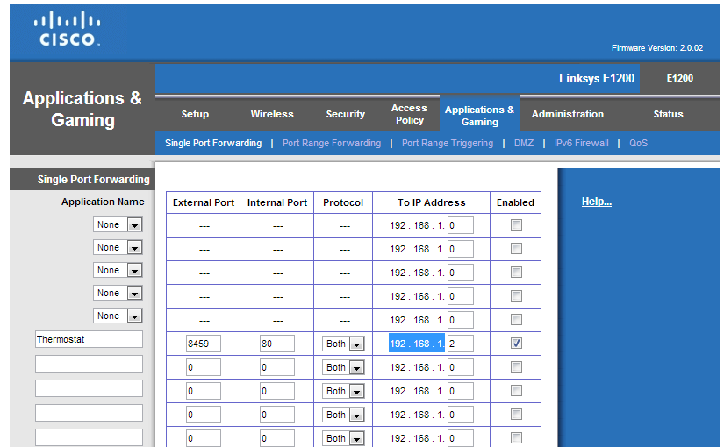

On the row that allows you to input information, type in an external port number. A common port number is 8080 but it can be anything. Type in the static ip address of the thermostat. The internal port number is 80 for reasons unbeknownst to me. Just use 80 if asked. After this is enabled and the settings are saved, go back to your browser.

In the browser type in your external ip address “:” your external port. This should now go directly back to your thermostat setup page, except that now it can be accessed from any network.

There are also multiple videos which explain the process of port forwarding which can be found on youtube.

Concerns:

The biggest concerns about port forwarding with the Filtrete thermostat is the lack of security. If someone else knows the address of your port, it will be possible for the other person to control your thermostat.

